**NSW SALERS REGIONAL REPORT**

Generally speaking the last year for NSW farmers hasn’t been an easy one.

Very rarely would you see drought conditions affecting every area of the state but to have 100% of the state drought declared I think is unprecedented. Not only NSW being in drought, but its neighbours as well has meant very high prices for grain and fodder which will continue, leaving little margins on returns.

Cattle numbers have decreased – one positive to take from this is that seed stock which have been kept should be of the highest calibre.

On a personal level we have culled animals that we otherwise would have kept. We have retained a group of steers which would have finished too heavy for our domestic butchers market and will now target a carcase competition in May 2019 via Wingham Beef Week and Wingham Beef Exports. In this group we have incorporated two purebred Salers

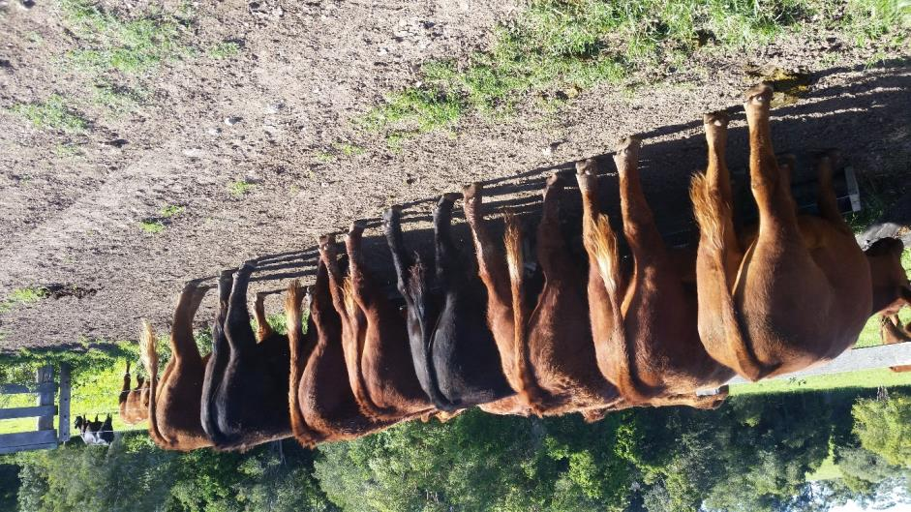

These steers have continued to gain weight with minimal rations so we’ll keep you posted as to their final weights and figures.

We recently had a visit from a former Salers member Welby and Marg Davidson from Toowoomba and we were delighted that Welby was “impressed” with our stock. He now lives in suburbia but thought he could possibly fence off some of the park behind his house and keep a heifer there which had really caught his eye!!!!!! ( Kintelah N6)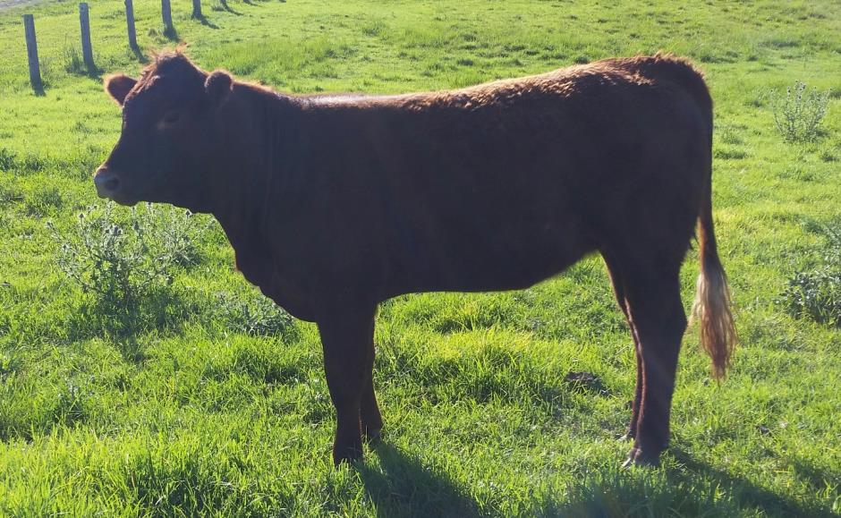

Another consideration of this prolonged drought will be conception rates. A planned AI program was dismissed and all females placed into one group with same bull so results will be comparable.

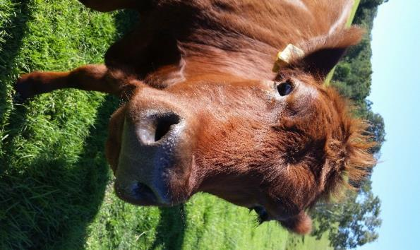

We are sorry to have missed the AGM and hope that you are having an enjoyable weekend.

All the very best for Christmas and may the New Year be kind to all.

Regards

Kathy